## EXP NO:01.A

## TITLE: Good design Bad design

**AIM:** To design a user interface app login page using figma.

**PROCEDURE:**

Bad UI Design Procedure

Step 1: Poor Project Setup

1. Sign up and create a New File, but use an incorrect frame size (e.g., desktop for mobile UI).

Step 2: Design a Cluttered Login Screen

* Background: Use a very bright or dark background with poor contrast.
* Logo: Make it too small or oversized, disrupting the visual balance.
* Input Fields:
  + Use sharp-edged rectangles with no padding.
  + No placeholder text, making fields unclear.
  + Poor contrast between text and background.
* Login Button:
  + Use a similar color to the background, making it hard to notice.
  + Small button size, making it difficult to tap.
  + No clear text or misleading labels.
* Alignment & Spacing:
  + Elements are randomly placed with uneven spacing.
  + No proper grouping, making the screen appear cluttered.

Step 3: Poor Prototyping & Interactions

* No proper linking of buttons to the next screen.
* Abrupt or no animation, making the transition jarring.

Step 4: Preview, Share, and Export Issues

* Preview: Not tested for usability or responsiveness.
* Share: No proper permissions set, making collaboration difficult.
* Export: Low-resolution or incorrect format, causing quality issues.

## **Good UI Design Procedure**

### **Step 1: Set Up the Project**

1. Sign up/log in to [figma.com](https://figma.com) and create a **New File**.
2. Use the **Frame tool (F)** to select a mobile preset (e.g., iPhone 13).

### **Step 2: Design a Clean Login Screen**

* **Background**: Use a light, pleasant color (#E3F2FD) for readability.
* **Logo**: Add a well-sized logo with appropriate spacing.
* **Input Fields**:
  + Use rounded corners and clear labels.
  + Add placeholder text (e.g., “Enter your email”).
  + Ensure proper contrast for legibility.
* **Login Button**:
  + Use a clear, high-contrast color (#1E88E5) with readable text.
  + Provide proper spacing from input fields.
  + Ensure touch-friendly size (at least 44x44 px).
* **Alignment & Spacing**:
  + Use **Auto Layout (Shift + A)** for consistent spacing.
  + Center elements properly and maintain a balanced layout.

### **Step 3: Prototype Interactions**

* Link the **Login** button to the next screen with **“On Click” → “Navigate to Home Screen”**.
* Apply smooth animations (**Smart Animate**) for a seamless transition.

### **Step 4: Preview, Share, and Export**

* **Preview**: Click the **Play** button to test interactions.
* **Share**: Use the **Share** button to invite collaborators with appropriate permissions.
* **Export**: Select assets, click **Export**, and choose formats like PNG, JPG, or SVG.

**BAD DESIGN**

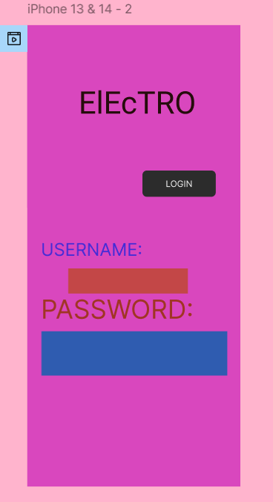

REASONS WHY THE ABOVE IS A BAD DESIGN:

1. Poor Color Contrast & Clashing Palette

* The background and text colors (pink, purple, blue, red, black) do not complement each other, making readability difficult.
* Low contrast between elements reduces accessibility.

2. Inconsistent Typography

* The app name ("ElEcTRO") uses inconsistent capitalization, making it look unprofessional.
* The font sizes and colors for "USERNAME" and "PASSWORD" labels do not maintain uniformity.

3.Misaligned & Disorganized Layout

* Elements are not properly aligned, creating a cluttered look.
* Input fields are placed awkwardly, making the form difficult to use.

4. Button Design Issues

* The "LOGIN" button is too small compared to the other elements.
* The black button on a vibrant background does not stand out clearly.

5. Lack of Spacing & Visual Hierarchy

* No clear separation between different sections (logo, input fields, button).
* Spacing between elements is inconsistent, affecting usability.

**GOOD DESIGN:**

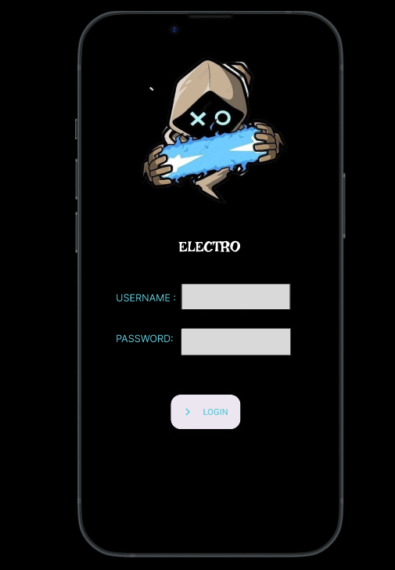

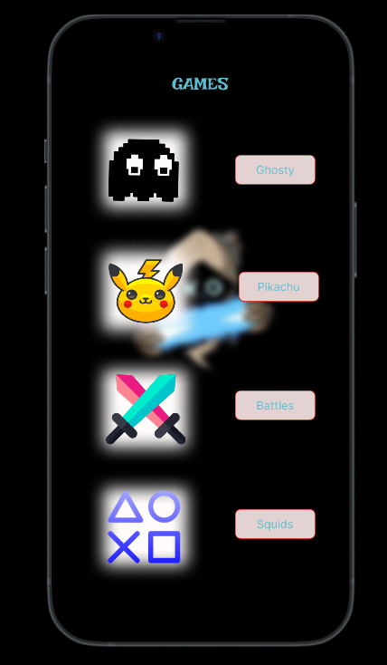

**Link:** <https://www.figma.com/proto/y7licszsTuAFExr7urZye9/Untitled?node-id=1-2&p=f&t=zNemXG0CUwYPqSls-1&scaling=scale-down&content-scaling=fixed&page-id=0%3A1>

**RESULT:** A user interface login page for an app is created in figma along with a bad and good design.